FTF FY 2023 Performance Scorecard USAID Guatemala

This Feed the Future (FTF) Performance Scorecard assesses the USAID Guatemala progress toward FY 2030 Performance Targets.

# Performance Overview



The FY 2023 **On track** value is determined by drawing a line from the baseline (FY 2022) to the FY 2030 Target. For FY 2023, Performance Targets are considered **On track** if they have reported at least 90% of that value.

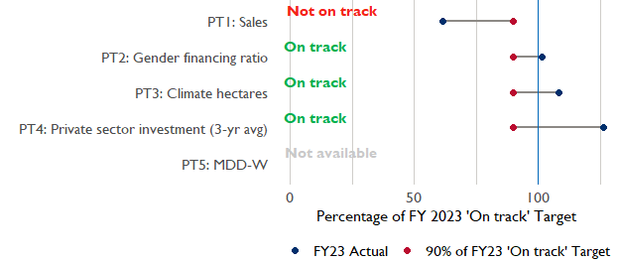

**Note:** *For Performance Target 2 (Gender financing ratio), the target is to increase financing to females for those OUs that are already achieving parity ($1).*

*For Performance Target 4 (PSI), all targets are relative to the last three years’ reporting. In future years, the interim targets may increase.*

*For Performance Target 5 (MDD-W), all FY23 actual values are also the baseline, and may have been collected in a prior year. See the detail page for more information.*

*See detailed* [*methodology document*](https://docs.google.com/document/d/13n-43ppFiGKauscQ7HaAiQDCM4DssGEgRdq2fMyTDn0/edit) *here. If you have questions, please email the FTF Data and Analytics team at* [refs.adl.da@usaid.gov](mailto:refs.adl.da@usaid.gov).

### Performance Target (PT) Details

This section shows PT scores for each applicable PT for USAID Guatemala.

## Performance Target 1: Value of annual sales of producers and firms receiving USG assistance



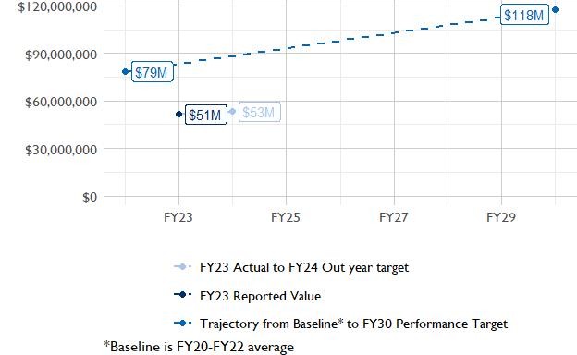

In FY 2023, USAID Guatemala had 4 activities that aligned the ‘Value of annual sales from producers and firms receiving USG assistance’ (EG.3.2-26), and 3 contributed to the sales total of $51,490,000.

###### Performance Target 2: Value of financing accessed by female FTF participants per $1 of financing accessed by male FTF participants



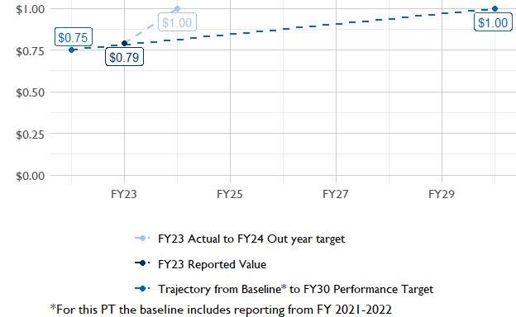

In FY 2023, USAID Guatemala had 2 IMs/Activities that reported all four sex disaggregates needed to contribute to PT2. The total value of financing among all activities, regardless of disaggregates, was $2,200,000 (EG.3.2-27 total), with $2,200,000 that was disaggregated by females and males, and an additional $5,000,000 to ‘mixed’ firms that have both males and females, and $2,580,000 that was not sex disaggregated.

###### Performance Target 3: Number of cultivated hectares under climate adaptation/climate risk management practices and technologies with USG assistance



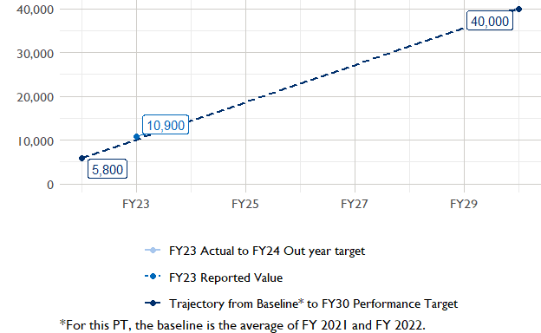

In FY 2023, Guatemala had 4 activities that aligned the indicator for hectares under improved management practices (EG.3.2-25). Of those activities, 1 reported on the ‘Climate adaptation/climate risk management’ disaggregate and contributed to the OU total for this PT.

###### Performance Target 4: Value of private sector investment leveraged by the USG to support food security and nutrition



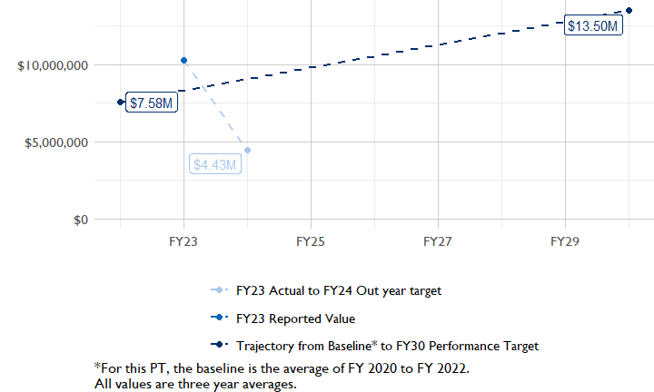

In FY 2023, Guatemala had 2 activities that aligned the private sector investment indicator (EG.3.1-15/-14), ‘Value of new private sector investment leveraged by the USG to support food security and nutrition [IM-level]’, and 2 contributed to the OU total in FY 2023.

###### Performance Target 5: Percent of women consuming a diet of minimum diversity (MDD-W)



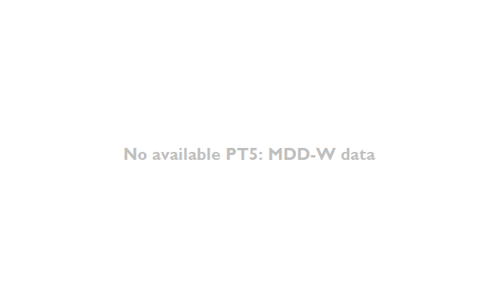

PT5 is not available for USAID Guatemala.

### National Context

National level data was collected from the [World Bank’s Open Data portal](https://data.worldbank.org/) that measures key indicators at the national level.

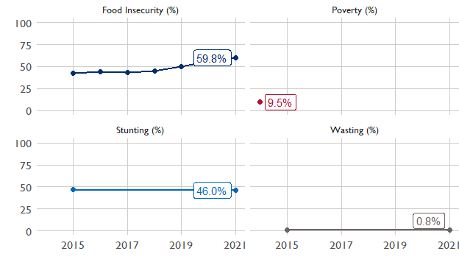

## Agricultural Transformation Index Score

The [IFPRI Agricultural Transformation Index (ATI)](https://agrilinks.org/events/drivers-agrifood-system-transformation-lessons-feed-future-country-studies) Score is a high level indicator of the status of agricultural market systems in each country.

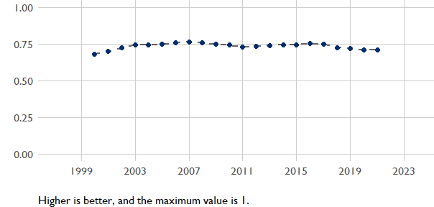

## Budget Trend

At the Operating Unit level, the Performance Targets are based in part on the FY 2024 budget request. The budget chart below includes EG.3 money only.

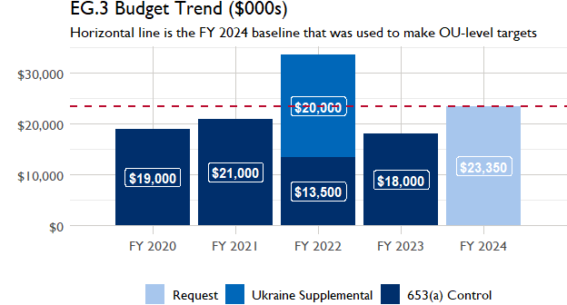

## Active Portfolio

The following activities are considered “active” based on their reporting in FY 2023 and expected FY 2024 reporting. The Analytics, Data and Learning Division defines an “active” activity as one that reported targets, actuals, or deviation narratives for the current year (FY 2023), or the next out year targets (i.e. FY 2024).

## Top Activities (Award Disbursements and Results)

This section highlights some activities in the USAID Guatemala (GUATEMALA) portfolio that have the highest level of disbursements and high reporting values for the relevant indicators. The table below shows the top (up to) five activities by the total transaction amount for disbursements. The columns to the right indicate if these activities are reporting on relevant PT indicators.

| Award Number | Activity Code | Activity Name | FY23 Disbursements | PT1 | PT2 | PT3 | PT4 |
| --- | --- | --- | --- | --- | --- | --- | --- |
| AID-520-A-17-00006 | 1494 | Feed the Future Guatemala Innovative Solutions for Agricultural Value Chains Project | $6,455,811 | X | X | X | X |
| 72052018CA00001 | 1493 | Feed the Future Guatemala Coffee Value Chains Project | $1,152,741 | - | - | - | - |

**The next table (below) shows the top reporting activities.**

| Award Number | Activity Code | Activity Name | Total Disbursements | Sales | Hectares | PSI |
| --- | --- | --- | --- | --- | --- | --- |
| AID-520-A-17-00006 | 1494 | Feed the Future Guatemala Innovative Solutions for Agricultural Value Chains Project | $6,455,811 | $39,558,344 | 10 866 | $5,452 |
| 72052021FA00002 | 5355 | Guatemala Entrepreneurship Development Initiative (GEDI) | NA | $7,207,639 | NA | NA |
| 72052018C00001 | 1485 | Creating Economic Opportunities | NA | $4,727,477 | NA | $9,815,596 |
| 72052018CA00001 | 1493 | Feed the Future Guatemala Coffee Value Chains Project | $1,152,741 | NA | NA | NA |

### Appendix 1: Response to “Not on track” Performance Targets

This section provides space for USAID Guatemala to provide an explanation of why the following PTs are not on track and how you could adjust to be on track in the coming year(s). To help in your response(s), the relevant section of the FTF/GFS Key Issue Narrative (KIN) is provided, as it *may be* useful in drafting a responses. Note that the KIN is addressing the sum of the out year targets (FY 2023) set by the USAID Guatemala activities that are reporting on each PT. The FY 2023 out year targets were set prior to the establishment of the FY 2030 Performance Targets, so the below explanations from the KIN may not apply to the Performance Target deviation.

* In Section 4 of the FTF KIN, your OU discusses FY24 and FY25 targets, while these Scorecards are addressing progress against a trajectory from historical reporting to your OU’s FY30 target.  Also, the FY 2023 out year targets were set prior to the establishment of the FY 2030 Performance Targets.  Therefore, the below explanations from the KIN may not apply to these FY30 Performance Target deviations.
* These responses will be used to compile a Congressional report, the GFSS Implementation Report, to discuss progress against the FTF FY 2030 Performance Targets, as mandated by the GAO.
* Only PTs that are ‘Not on Track’ require review and explanation from the OU.

## Performance Target 1: Sales

*Excerpt from FY23 KIN Section 4 to consider:*FY23, three activities generated $51,493,461 million in sales, which exceeds the $47.2 million target. FtF expects to meet and not exceed significantly the FY24 of $53.8 million and $60 million in FY25 because CEO and GEDI will not receive more FtF funds in FY24. Disaggregating the $51 million total shows that the ProInnova activity contributed nearly 77% of sales results, or $39.5 million, due to intensified efforts to increase the sales of organized and individual producers in the national market, as well as renewing and creating alliances with strategic partners to bolster international market sales in 2024. The target was exceeded due to the GEDI activity’s sales of $7.2 million versus their target of $477,000. This is due to the timing in reporting and design of GEDI which was able to recruit additional partners after the target was set. Overall, GEDI 2023 results are consistent with the goals recalculated during this year, and it will be regularized at the end of this activity, since this is an accurate reflection of planned stakeholders in FY 2023. CEO is the third contributor and provided specialized technical and financial assistance to 37 companies in agricultural value chains and achieved $4.73 million in sales through 19 of these companies. This far exceeded and doubled the CEO target of $1.7 million and was due to the addition of new companies in 2023 and exponential sales of a CEO-supported FtF company, Conservas y Congelado Ya Esta S.A., which was approved in December 2020. With CEO support for feasibility studies for business expansion, including architectural designs and plans, the company secured $5 million in May 2023, brought another 1,000 small-scale producers into its production lines, and generated 120 new jobs in its factory in Guatemala City. This company produces preserves, sauces, and corn-derived products and sauces for a diaspora market overseas and for traditional dishes in Guatemala.

#### Enter USAID Guatemala (GUATEMALA) Response Below: